# Software Design Description

## Design Overview

## System Architectural Design

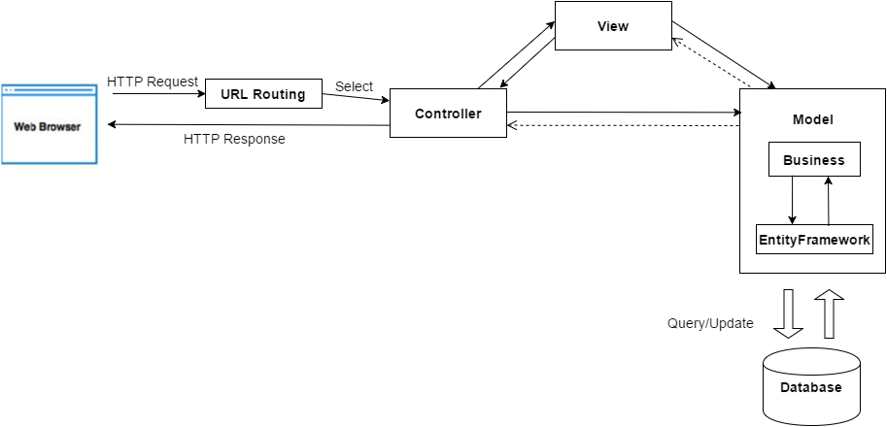

Figure 35: IMS System Architectural

We use MVC architecture style to develop IMS web. Specifically, customized it as convenient and suitable as possible to meet the customer’s requirement.

Controller: Receive requests from clients and transfers to Business to handle request then use processed result from Business to render View and return view to clients.

View: handles for display data from Model. The creation of View is under control of Controller.

Model: is generated by mapping database table by Entity Framework 6, Model is used like a data transfer object between the system and database.

Business: Handles the business logic of the system.

## Component Diagram

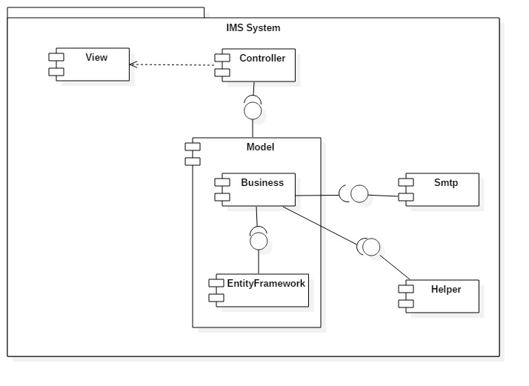

Figure 36: Component Diagram

|  |  |
| --- | --- |
| Component dictionary | |
| Component Name | Description |
| Controller | Contain all controllers in the system. |
| View | Contain all views in the system. |
| Business | Contain all business logic processing in the system. |
| Model | Entity Framework 6 mapping models. |
| Smtp | Component is used to send asynchronous emails. |
| EntityFramework | Component is used to map database table, generate Model. |
| Helper | Contain all libraries which are used to develop the system. |

Table 38: Component Dictionary

## Detailed Description

### Class Diagram

Figure 37: Class Diagram

### Class Diagram Explanation

### Interaction Diagram

#### <Customer> Add server

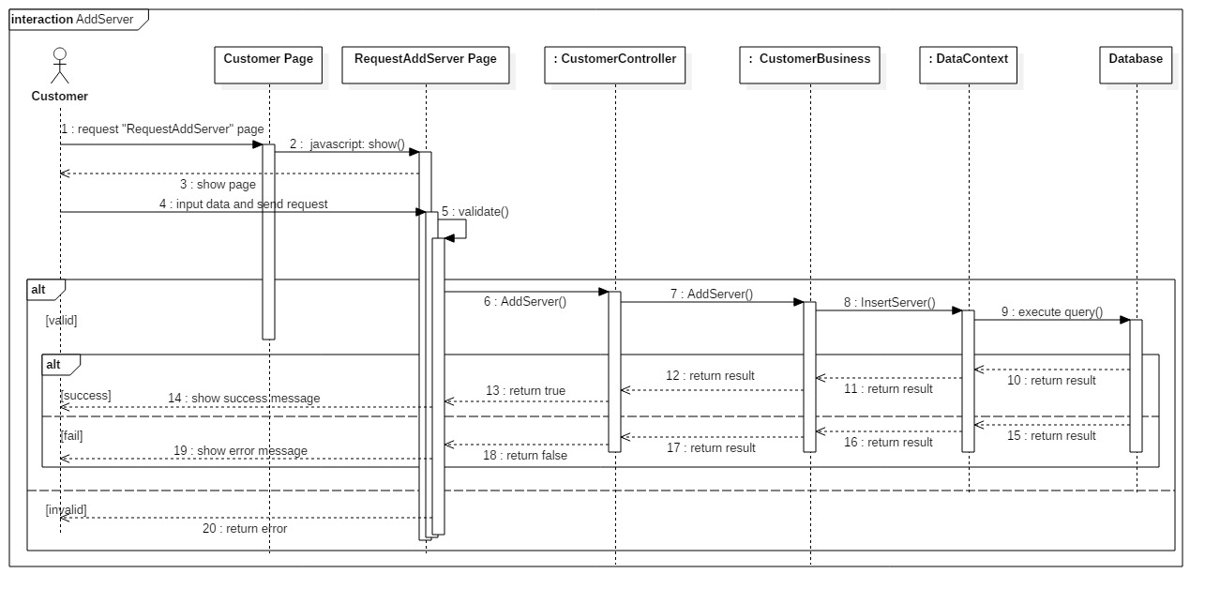**Summary:** This diagram shows how the customer add a new server into data center.

Figure 38: Sequence Diagram <Customer> Add server

#### <Customer> Update request Add New Server

**Summary:** This diagram shows how customer to update request Add New Server.

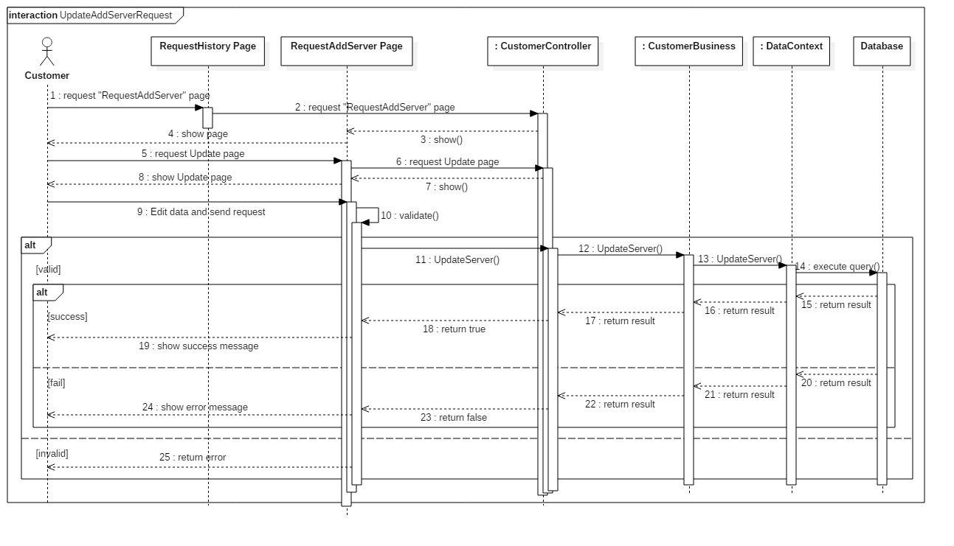

Figure 39: Sequence Diagram <Customer> Update request Add New Server

#### <Customer> Cancel request Add New Server

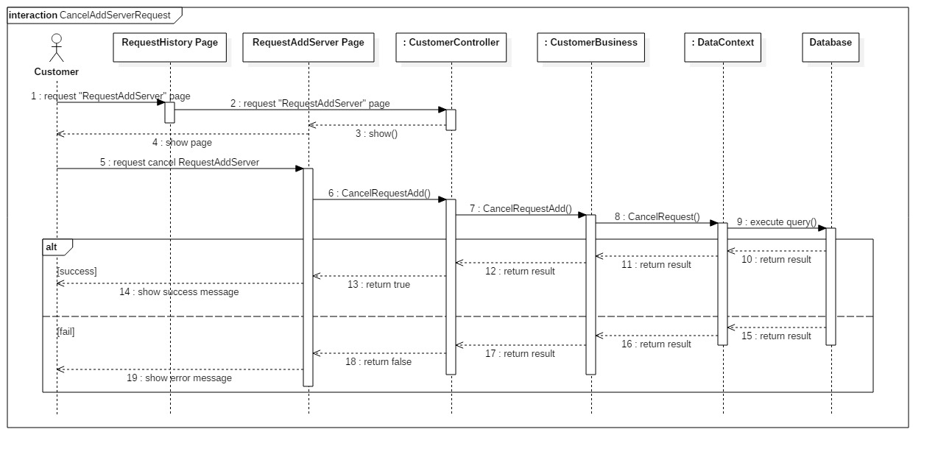**Summary:** This diagram shows how customer cancel request Add New Server.

Figure 40: Sequence Diagram <Customer> Cancel request Add New Server

#### <Customer> Return IP

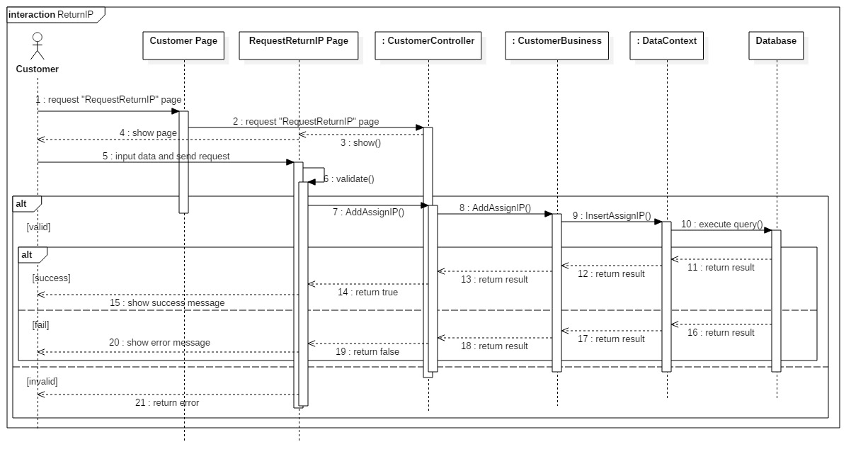**Summary:** This diagram shows how customer return IP Address to data center.

Figure 41: Sequence Diagram <Customer> Return IP

#### <Shift Head> Assign IP to server

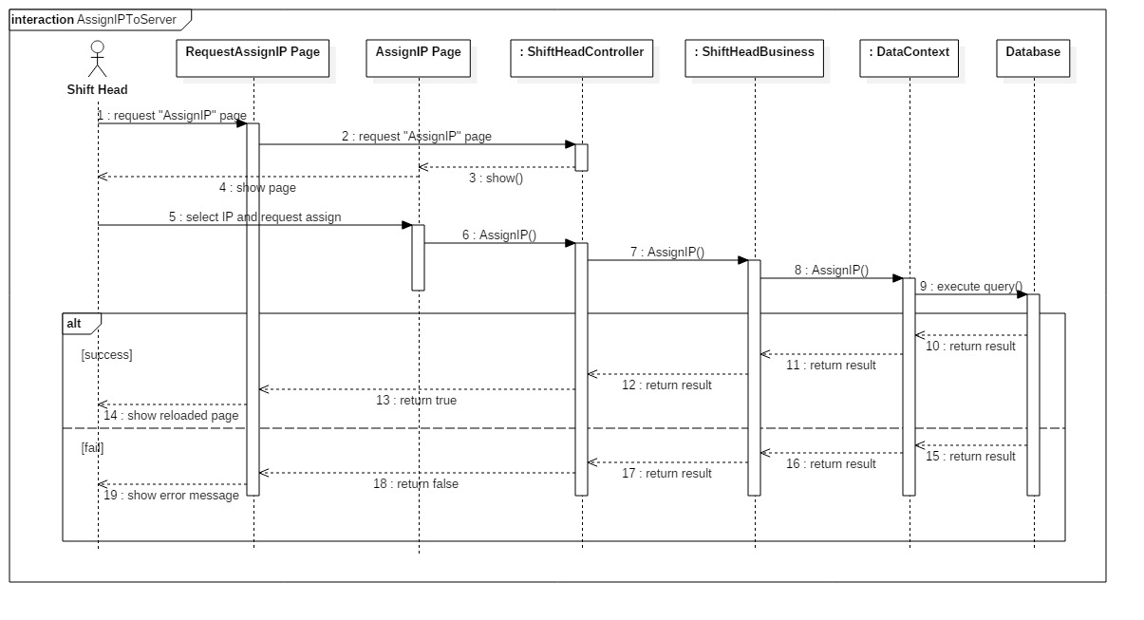**Summary:** This diagram shows how Shift Head assign IP Address to server.

Figure 42: Sequence Diagram <Shift Head> Assign IP to server

#### <Shift Head> Assign task

**Summary:** This diagram shows how Shift Head assign task for Staff.

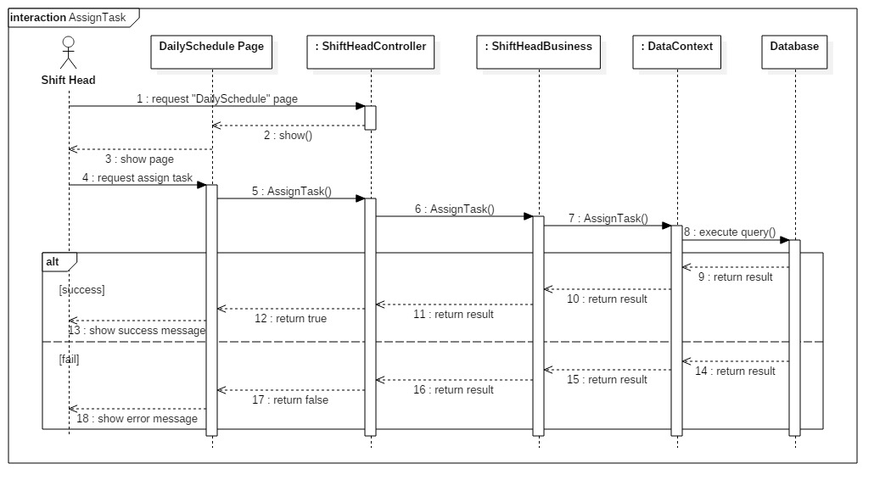

Figure 43: Sequence Diagram<Shift Head> Assign task

#### <Shift Head> Approve request Add New Server

**Summary:** This diagram shows how Shift Head approve request Add New Server from customer.

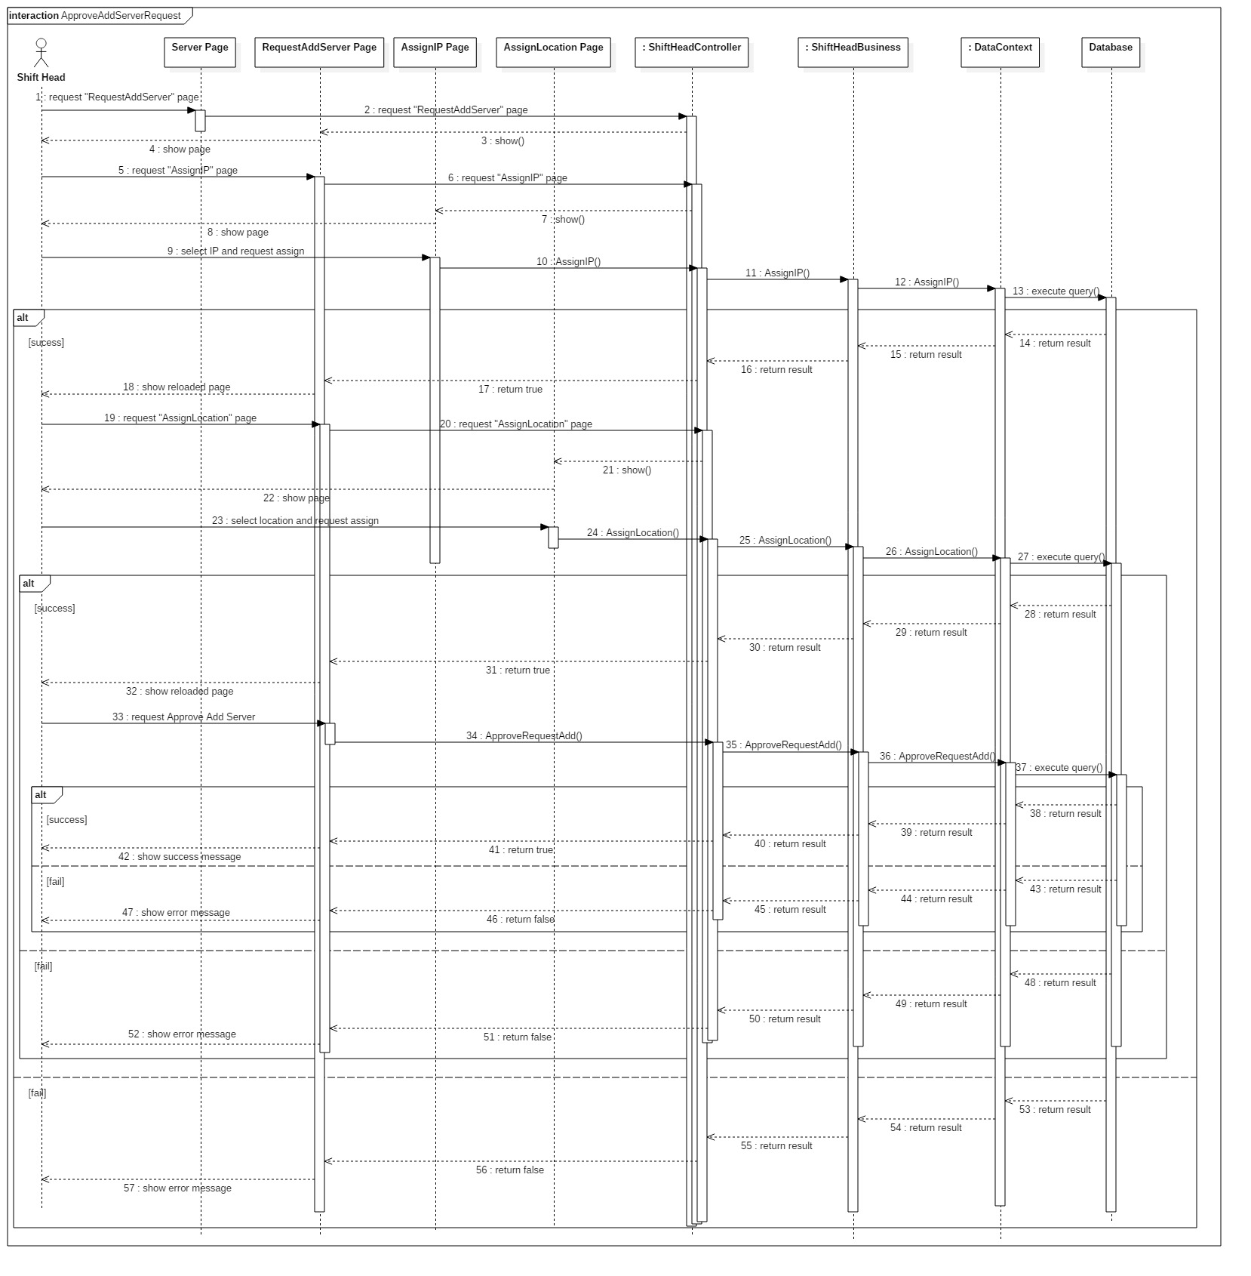

Figure 44: Sequence Diagram <Shift Head> Approve request Add New Server

#### <Shift Head> Approve request Change IP Address

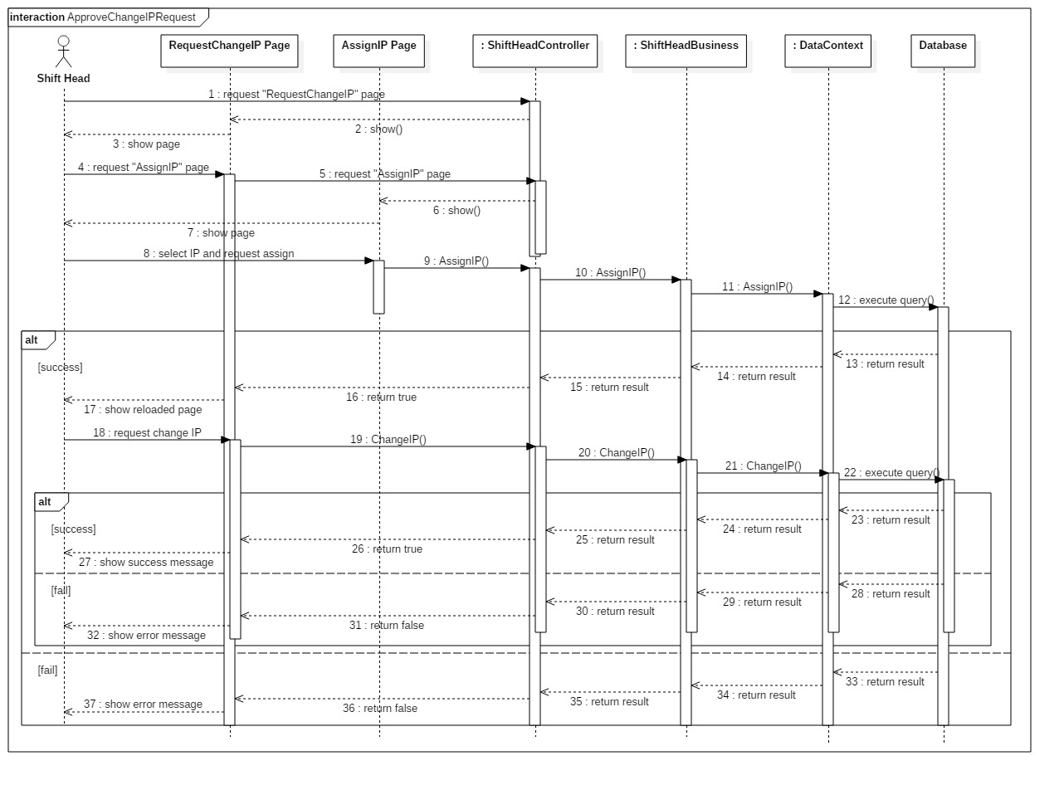**Summary:** This diagram shows how Shift Head approve request Change IP Address from customer.

Figure 45: Sequence Diagram <Shift Head> Approve request Change IP Address

#### <Shift Head> Change IP Status

**Summary:** This diagram shows how Shift Head change status of IP Address.

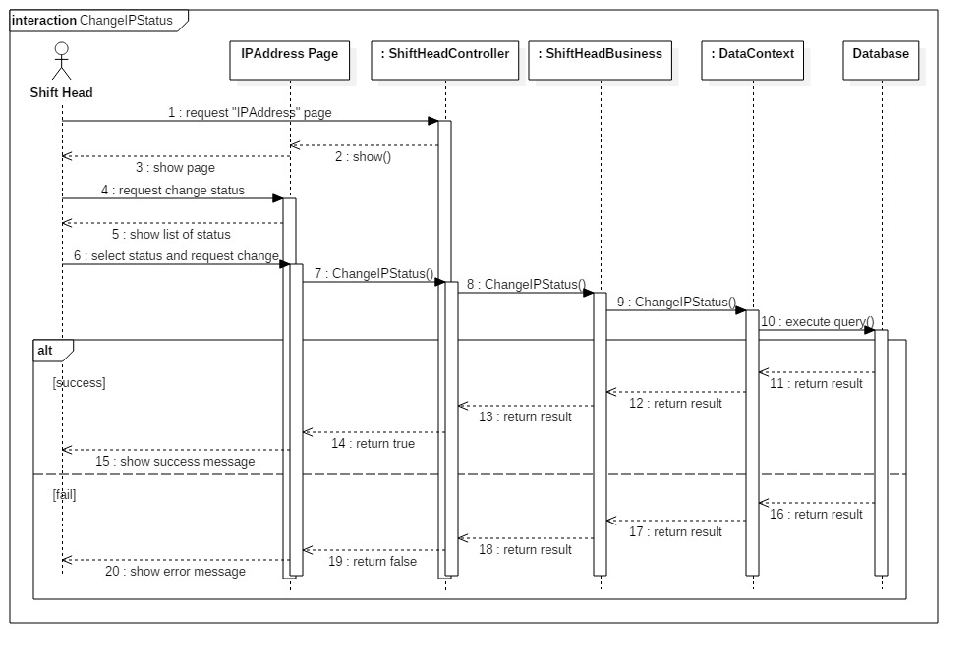

Figure 45: Sequence Diagram <Shift Head> Change IP Status

#### <Shift Manager> Add Staff

**Summary:** This diagram shows how Shift Manager add new Staff into the system.

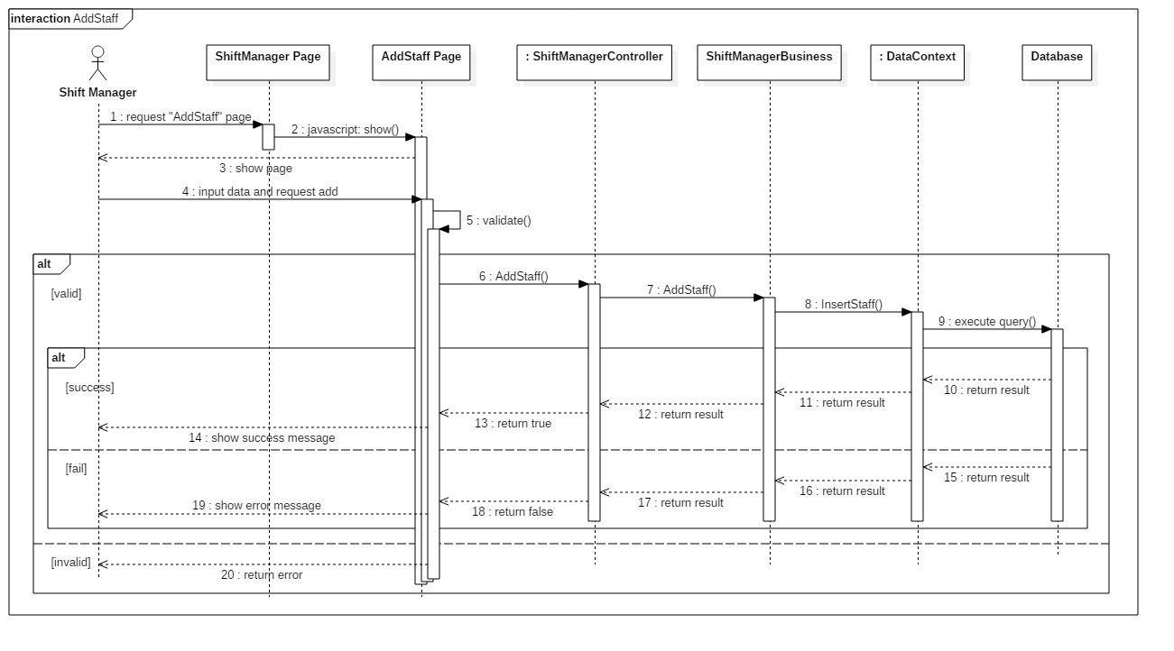

Figure 45: Sequence Diagram <Shift Manager> Add Staff

## User Interface Design

## Database Design

### Logical Diagram

Figure 68: Logical Diagram

### Data Dictionary

|  |  |
| --- | --- |
| **Entity Data dictionary: describe content of all entities** | |
| Entity Name | Description |
| Server | Describe all servers of customer in data center. |
| ServerAttribute | Describe all Option Attributes which customer can add depend on server. |
| Location | Describe all location in data center. |
| Rack | Describe all racks which are putting in data center. |
| LogChangedContent | Describe the history of each time when something was changed. |
| Object | Describe all objects of the system. |
| TypeOfLog | Describe all types of log. |
| Role | Describe all roles in the system. |
| ServerIP | Describe all of current IP Addresses of each server. |
| Request | Describe content of each request which was sent by customer. |
| Account | Describe all user’s accounts in the system. |
| Status | Describe all statuses of objects of the system. |
| IPAddressPool | Describe all IP Addresses which data center is keeping. |
| RequestType | Describe all type of request. |
| Group | Describe all the shift groups. |
| AssignedShift | Describe all the shifts of each day. |
| Shift | Describe started time and ended time of each shift group. |
| RackOfCustomer | Describe all racks of customer in data center. |
| StaffAssignment | Describe all information of each assignment for Staff. |
| Attribute | Describe all general attributes of a sever. |

*Table 9: Entity Data Dictionary*

|  |  |  |  |  |
| --- | --- | --- | --- | --- |
| **Entity name** | **Attributes** | **Description** | **Domain** | **Null** |
| Role | Id | Unique identifier of a role | int | No |
| RoleName{PK} | Role Name, unique identifier of a role | varchar(10) | No |
| Account | Id | Unique identifier of an account | int | No |
| Username | Username of an account, identifier of an account | varchar(30) | No |
| Password | Password of an account | varchar(20) | No |
| Role{FK} | ID of account’s role | int | No |
| Email | Email address | varchar(50) | No |
| Fullname | Full name of user | nvarchar(150) | No |
| Phone | Phone of user | varchar(50) | No |
| Address | Address of user | nvarchar(150) | No |
| Identification | Identification Number of user | varchar(50) | No |
| Status{FK} | Current status of user | bit | No |
| Server | ServerId{PK} | Unique identifier of server, auto increment. | int | No |
| CustomerId{FK} | ID of customer who own this server | int | No |
| Maker | The maker of server | nvarchar(50) | No |
| Modern | The modern of server | nvarchar(50) | No |
| Power | The power of server | int | No |
| Size | The size of server: 1U, 2U or 4U | int | No |
| Status | Current status of server. | varchar(50) | No |
| LocationId{FK} | ID of server’s location | int | Yes |
| DefaultIPId{FK} | ID of default IP of server | int | Yes |
| RegisteredDate | The date when server was registered. | date | No |
| RequestId{FK} | ID of the request to add this server into data center | int | No |
| ServerAttribute | AttributeId{PK} | Unique identifier of server’s attribute | int | No |
| ServerId{FK} | ID of server which have this attribute | int | No |
| AttributeName | Name of the attribute | varchar(150) | No |
| AttributeValue | Value of the attribute | varchar(150) | No |
| RequestId | ID of the request to add this attribute | int | No |
| IsLastest | The status of attribute: is lastest or not | bit | No |
| LogUpgradedServer | LogId{PK} | Unique identifier of Log table of upgraded server | int | No |
| ServerId{FK} | ID of server which was upgraded | int | No |
| StaffId{FK} | ID of Staff who recorded this log | int | No |
| UpgradedContent | The upgraded content of server | nvarchar(MAX) | No |
| LogTime | The time when logged | datetime | No |
| RequestId{FK} | ID of the request to upgrade server | int | No |
| LogServerDelivery | LogId{PK} | Unique identifier of Log table of Server’s Delivery | int | No |
| ServerId{FK} | ID of server which was delivered | int | No |
| StaffId{FK} | ID of Staff who carried | int | No |
| IsOut | Server’s status is out or in data center | bit | No |
| LogTime | The time when logged | datetime | No |
| RequestId{FK} | ID of the request to deliver server | int | No |
| ServerIP | Id{PK} | Unique identifier of table current IP of server | int | No |
| ServerId{FK} | ID of server | int | No |
| CurrentIPId{FK} | ID of Current IP of server | int | No |
| IPAddressPool | Id{PK} | Unique identifier of all IP Addresses | int | No |
| IPAddress | IP Address of data center | varchar(50) | No |
| Status | Current status of IP Address | varchar(50) | No |
| Gateway | Gateway of IP Address | varchar(50) | No |
| Subnetmask | Subnetmask of IP Address | varchar(50) | No |
| StaffId{FK} | ID of staff who added IP Address into system | int | No |
| RegisteredDate | The date when IP Address was added into system | date | No |
| RequestType | RequestTypeId{PK} | Unique identifier of a request type | int | No |
| RequestType | Name of request’s type | nvarchar(50) | No |
| LogConfirmedRequest | LogId{PK} | Unique identifier of Log table of confirmed request | int | No |
| RequestId{FK} | ID of request | Int | No |
| StaffId{FK} | ID of Staff who confirmed request | int | Yes |
| ServerId{FK} | ID of server in confirmed request | int | Yes |
| ChangeIPAddressId{FK} | IP Address in confirmed request | int | Yes |
| IsConfirmed | The request’s status which was confirmed or not | bit | No |
| Comment | The comment of Staff when confirmed | nvarchar(MAX) | Yes |
| LogTime | The time when Staff confirmed request | datetime | Yes |
| LogServerMoving | LogId{PK} | Unique identifier of Log table of Server’s moving | int | No |
| ServerId{FK} | ID of server which was moved | int | No |
| MovedLocationId{FK} | ID of the location which was moved on | int | No |
| StaffId{FK} | ID of staff who moved server | int | No |
| Reason | The reason why moved server | nvarchar(MAX) | Yes |
| LogTime | The time when logged | datetime | No |
| LogIPAllocation | LogId{PK} | Unique identifier of Log table of IP Address Allocation | int | No |
| ServerId{FK} | ID of server which was allocated IP Address | int | No |
| AssignedIPId{FK} | ID of IP Address which was assigned | int | No |
| StaffId{FK} | ID of Staff who assigned IP Address to server | int | No |
| LogTime | The time when logged | datetime | No |
| RequestId{FK} | ID of request which assigned IP Address | int | No |
| Location | LocationId{PK} | Unique identifier of all locations of data center | int | No |
| RackId{FK} | ID of rack which contain location | int | No |
| RackUnit | Rack Unit of location | int | No |
| Status | The current status of location | bit | No |
| LogIPStatus | LogId{PK} | Unique identifier of Log table about change IP Status | int | No |
| IPAddressId{FK} | ID of IP Address which was changed status | int | No |
| ChangedStatusTime | The time when IP Address’s status was changed | datetime | No |
| Status | Status of IP Address which was changed | varchar(50) | No |
| StaffId{FK} | ID of Staff who changed status of IP Address | int | No |
| Reason | Reason why changed status of IP Address | nvarchar(MAX) | Yes |
| Request | RequestId{PK} | Unique identifier of a request | int | No |
| RequestTypeId{FK} | ID of request’s type | int | No |
| CustomerId{FK} | ID of customer who created request | int | No |
| AppointmentTime | The time when customer registered to have appointment with data center | datetime | Yes |
| Description | The description of customer in request | nvarchar(MAX) | Yes |
| RequestedTime | The time when request was created | datetime | No |
| LogRequestStatus | LogId{PK} | Unique identifier of Log table of request’s status | int | No |
| RequestId{FK} | ID of request | int | No |
| StaffId{FK} | ID of staff who changed status of request | int | No |
| Status | The current status of request | varchar(50) | No |
| ChangedStatusTime | The time when request’s status was changed | datetime | No |
| Rack | RackId{PK} | Unique identifier of rack | int | No |
| RackNumber | Numerical order of rack | int | No |
| RegisteredDate | The date when rack was added into data center | date | No |
| LogNote | LogId{PK} | Unique identifier of Log table of staff’s note | int | No |
| StaffId{FK} | ID of Staff who logged note | int | No |
| Description | Description of staff | nvarchar(MAX) | No |
| LogTime | The time when logged | datetime | No |
| StaffAssignment | Id{PK} | Unique identifier of staff’s assignment | int | No |
| StaffId{FK} | ID of Staff who was assigned | int | No |
| ShiftHeadId{FK} | ID of Shift Head who assigned | int | No |
| RequestId{FK} | ID of request which Shift Head assigned to Staff | int | No |
| AssignmentStatus | Status of assignment | varchar(50) | No |
| ChangedStatusTime | The time when assignment’s status was changed | datetime | No |
| ShiftGroup | GroupId{PK} | Unique identifier of shift’s group | int | No |
| StaffId{FK} | ID of Staff who is in group | int | No |
| GroupName | The name of group | varchar(50) | No |
| JoinedDate | The date when staff joined group | date | No |
| Shift | Id{PK} | Unique identifier of shift | int | No |
| Shift | Name of shift | varchar(50) | No |
| GroupId{FK} | ID of shift’s group | int | No |
| StartedTime | The time when shift started | datetime | No |
| EndedTime | The time when shift ended | datetime | No |

*Table 10: Detail Data Dictionary*

## Algorithms

### Academic classification

Figure 69: Academic classification main flow

Figure 70: Academic classification sub-flow 1, 2, 3, 5

Figure 71: Academic classification sub-flow 4, 6

### Consider of honor

Figure 72: Consider Honor

### Consider of upgrading

Figure 73: Consider Upgrading

### State Machine Diagram for Request Status

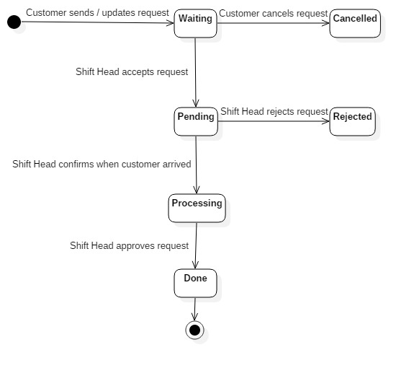

Figure 74: State Machine Diagram for Request Status

### State Machine Diagram for Staff Assignment Status

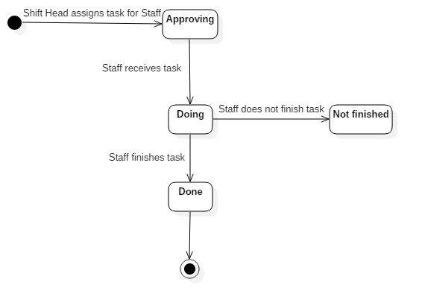

Figure 75: State Machine Diagram for Staff Assignment Status

### State Machine Diagram for Server Status

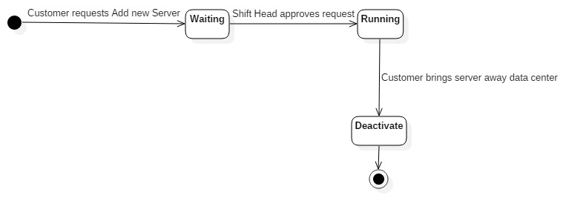

**Figure 75: State Machine Diagram for Server Status**